Université PARIS - PANTHÉON - ASSAS U.E.C. 1

Droit - Economie - Sciences Sociales L27032AT

Paris & Melun

Session : Janvier 2023

Année d'étude : 2022-2023

Discipline : Anglais 1° semestre

(Unités d’Enseignements Complémentaires 1)

Titulaire(s) du cours : Elizabeth Dodard (coordinatrice)

Durée de l’épreuve : 1h30

Document(s) autorisé(s) : aucun document n’est autorisé.

Durée de l’épreuve : 1h30.
Ce sujet comporte 6 pages. Avant de composer, veuillez vérifier que votre sujet est complet.
***

Vous rédigerez vos réponses sur les feuilles numérotées 5 et 6.

1. Use the text and charts on the next pages to write a synthesis on the American climate policy /8
To organize your synthesis, follow the guidelines and answer the questions on pages 5 & 6.
Do not borrow sequences longer than 2 words from the original text.
Do not forget to start paragraphs 2,3 & 4 with a topic sentence.

2. You must ABSOLUTELY use the four grammar points detailed below. They must be correct and coherently included in the logic of your synthesis. /2

- a first conditional
- a predictive sentence with a passive verb.
- a modal auxiliary with a passive verb.
- a double comparative

Do not forget to underline these forms or they will not count in your mark.
Document 1: US faces challenges in bid to hit Paris goals

Joe Biden’s flagship economic legislation represents the largest single US investment in climate and clean energy programmes in the country’s history. But even more work is needed if the world’s leading economy is to meet its Paris climate goals, analysts say.
The US has committed to reducing its greenhouse gas emissions by 50 to 52 per cent below 2005 levels by 2030. When all the effects of the recent legislation, called the Inflation Reduction Act, are factored in, research from Rhodium Group suggests that the country is on track for a 31 to 44 per cent reduction.
So, to make up the shortfall, Rhodium reckons the US will need more federal regulation to limit power plants’ emissions and decrease those from cars and trucks. Also required will be more climate-friendly infrastructure and transport policies from states, and the faster retirement of coal- and gas-fired power stations.
In modelling how the US could halve its emissions by 2030, the researchers assumed that all power companies that promised to transition to becoming 100 per cent clean moved their targets forward to 2035.
The Inflation Reduction Act seeks to enable this with some of the most significant legislation to mitigate climate change enacted in the US, committing $369bn to environmental and clean energy initiatives. It passed in August, though Congress may block further proposals by the Biden administration if the Republicans win a majority in either the Senate or House of Representatives in today’s midterm US elections.
Central to the programme are billions of dollars of tax credits designed to supercharge development of a US clean energy industry and speed the adoption of electric vehicles across the country.
About $30bn in grants and loans are available to utilities to help their transition to clean energy, while $6bn in grants and tax credits are available to help some of the worst polluters in industrial manufacturing — including chemical, steel and cement plants — to lower their emissions.
A further $27bn is aimed at supporting the rollout of nascent technologies that reduce emissions and $20bn for rural communities to invest in climate-friendly agricultural practices, forest restoration and land conservation.
Tax credits are also available to prospective buyers of electric cars and to poorer people who want to switch from oil or gas heating of their homes or install green technologies, such as heat pumps and solar panels.
Biden’s approach contrasts sharply with that of his predecessor, Donald Trump, who announced in 2017 that he would withdraw the US from the Paris accord, struck in 2015. The US left in 2020, then rejoined under Biden.
But the current administration has suffered setbacks to its ambitions to reach the Paris goal, including a recent ruling by the Supreme Court that curtailed the power of the US’s top environmental regulator.
In July, the court’s conservative majority struck down an obsolete Obama-era plan to shift power generation away from coal-fired plants and towards renewable sources across the American energy grid.
The ruling throws the regulatory power of the Environmental Protection Agency into doubt.
Meanwhile, Russia’s war in Ukraine has prompted a European energy crisis, drawn political attention to the increase in US petrol prices, and forced Biden both to cut federal fuel taxes and release millions of barrels of oil from strategic reserves.
Climate advocates have also criticised the Biden administration for backing the expansion of infrastructure for liquefied natural gas imports across Europe, and for meeting Japanese officials earlier this month to discuss US LNG exports to the country.
Collin Rees, of environmental campaign group Oil Change International, says that while the IRA moved the US towards significantly reducing its emissions, the US is not doing enough to reduce emissions globally.
(613 words)
Adapted from The Financial Times (Aime Williams in Washington, NOVEMBER 8 2022)
Document 2:
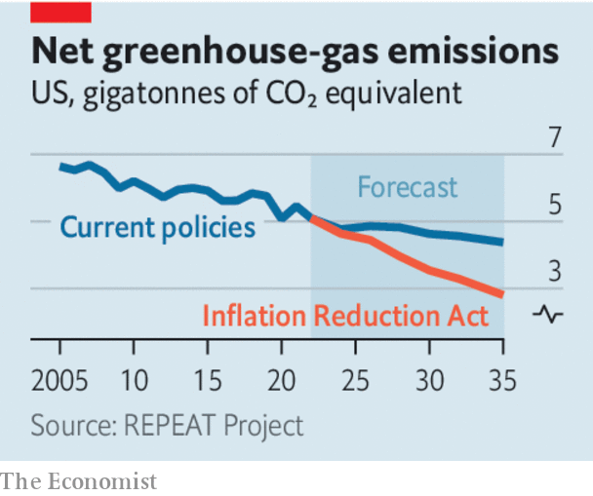
Source: The Economist, August 8th, 2022

Document 3:
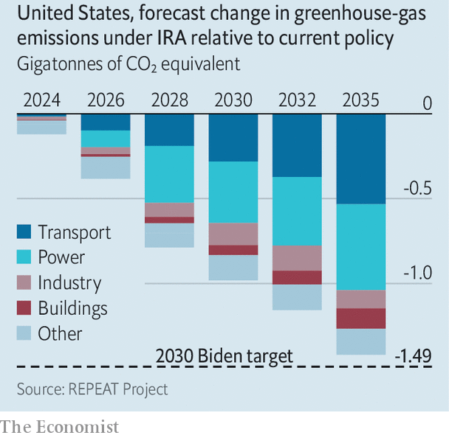
Source: The Economist, August 9th, 2022

INSCRIVEZ VOTRE MATRICULE : ………………………………………………………………………………

1) Write a 30-word introduction
……………………………………………………………………………………………………………………………………………………………………………………………………………………………………………………………………………………………………………………………………………………………………………………………………………………………………………………………………………………………………………

- Present the environmental measures passed through the IRA. (90 words)
………………………………………………………………………………………………………………………………………………………………………………………………………………………………………………………………………………………………………………………………………………………………………………………………………………………………………………………………………………………………………………………………………………………………………………………………………………
………………………………………………………………………………………………………………………………………………………………………………………………………………………………………………………………………………………………………………………………………………………………………………………………………………………………………………………………………………………………………………………………………………………………………………………………………………
…………………………………………………………………………………………………
…………………………………………………………………………………………………

- Do these measures suffice for the US to meet Paris goals? Justify. (90 words)
………………………………………………………………………………………………………………………………………………………………………………………………………………………………………………………………………………………………………………………………………………………………………………………………………………………………………………………………………………………………………………………………………………………………………………………………………………
………………………………………………………………………………………………………………………………………………………………………………………………………………………………………………………………………………………………………………………………………………………………………………………………………………………………………………………………………………………………………………………………………………………………………………………………………………
…………………………………………………………………………………………………
…………………………………………………………………………………………………

- Are there other challenges to the Biden administration’s climate targets? Justify. (60 words)
………………………………………………………………………………………………………………………………………………………………………………………………………………………………………………………………………………………………………………………………………………………………………………………………………………………………………………………………………………………………………………………………………………………………………………………………………………
…………………………………………………………………………………………………………………………………………………………………………………………………………………………………………………………………………………………………………………………………………………………………………………………………………

- Write a short conclusion (30 words)
………………………………………………………………………………………………………………………………………………………………………………………………………………………………………………………………………………………………………………………………………………………………………………………………………………………………………………………………………………………………………………………………………………………………………………………………………………

